Linear regression is a machine learning algorithm used to predict value of a variable.

Eg: we have data

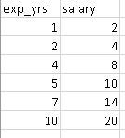

After plotting it will look like this:

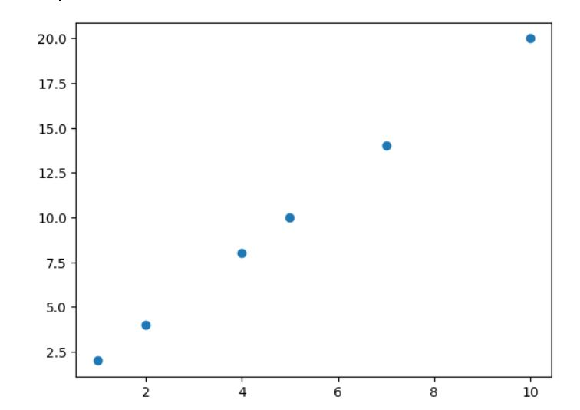

Now we need to ***find the salary of an employee who has worked 8 years***. (we don’t have that in our data)

To find the prediction of the algorithm ,***we should draw the linear regression line:***

Formula is: also referred as Y=mx+c

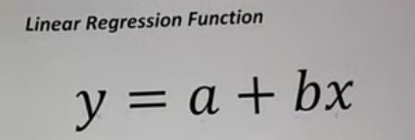

Now, y (y-axis) is the salary that we want to predict.

a is the y- intercept (i.e the regression line will pass through it on y axis)

b is slope of line

x(x-axis) is the experience of employee by years

we need to find slope (b):

formula

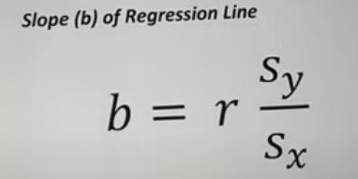

r is Pearson’s correlation coefficient

sy is std of y & sx is std of x.

to find these:

r =

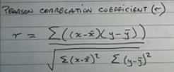

sy (standard deviation of y)=

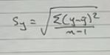

same goes with x.

now after solving we get slope(b).

In formula we can put b in y = a +bx,

Now a (y-intercept)?,

Formula: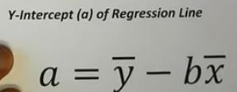

Put all values in y = a+bx…. (x is the exp year of employee that we are predicting the salary for)

**Solving the problem Mathematically:-**

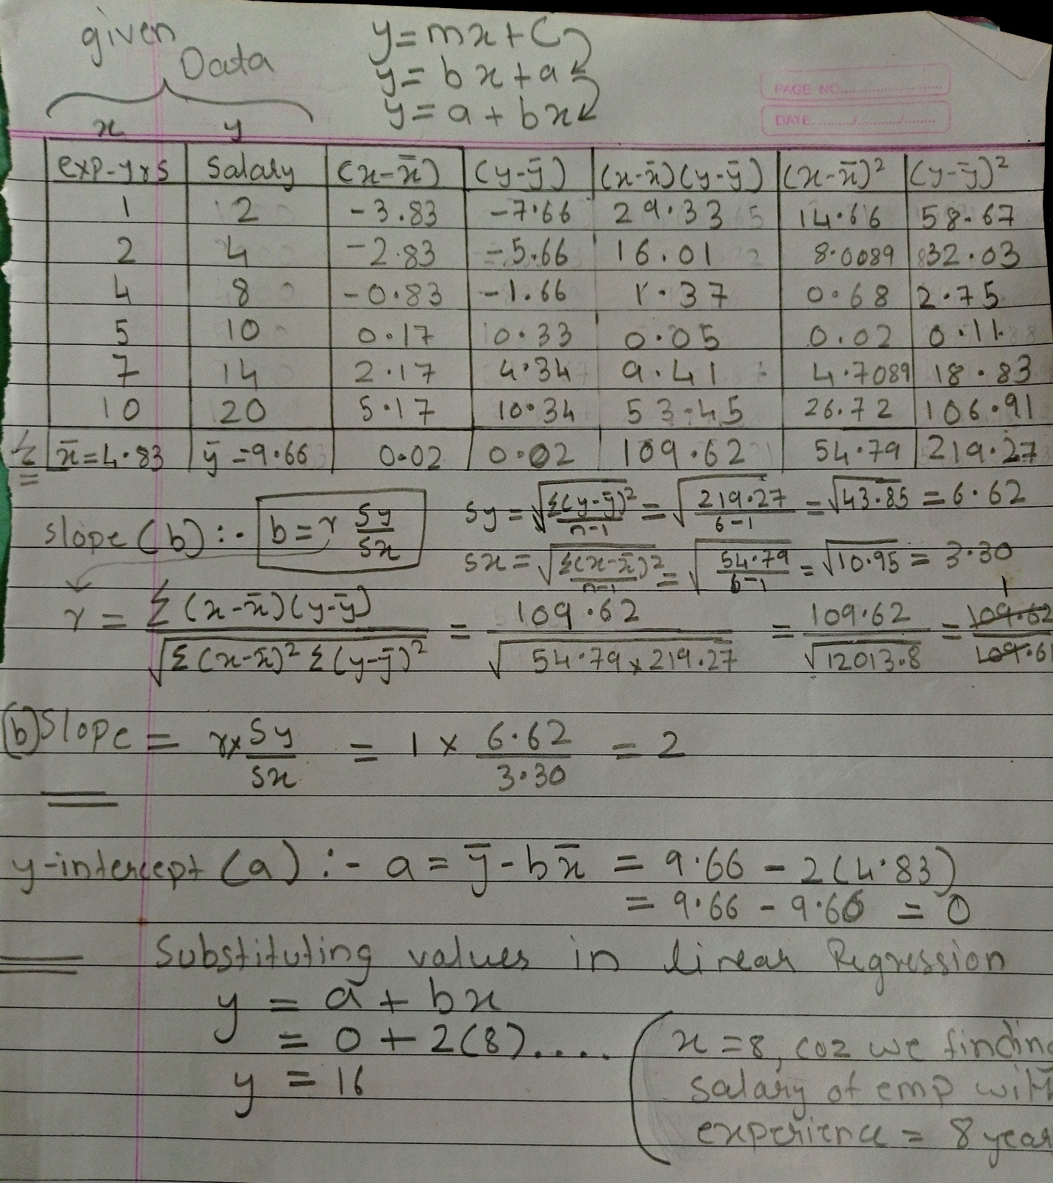

Here you can see that,

b=2 , a = 0.

Hence, when x=8.

Ans: y=16.

Graphically:-

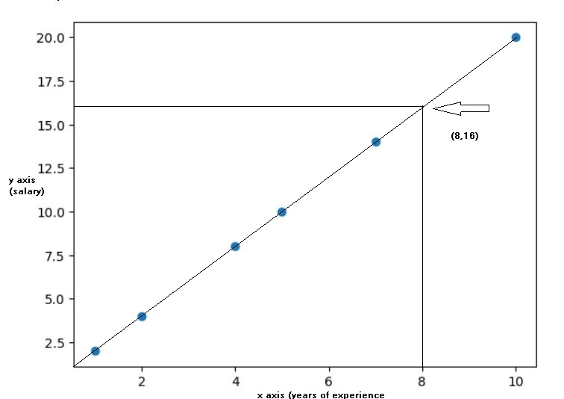

Now lets find it using python:-